**My Secret Formula for Writing a Great Profile**

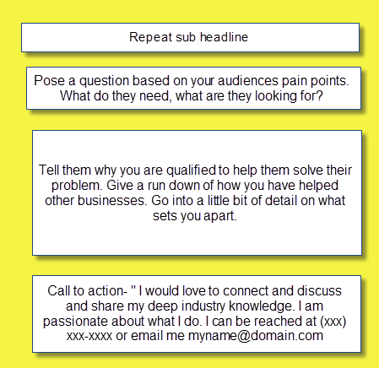

So that’s pretty much it. **To summarize:**

* Do make it in first person- you are selling yourself
* Don’t make it sound like a resume- most people make that mistake
* Don’t make it a copy and paste of your resume (did I say that already☺)
* Do write it as sales or marketing copy- think of it as your brochure and your 30 second commercial selling yourself and your services.
* Everyone likes a great story- tell a story about you and why you can help them solve their problem.
* End with a great call to action and make it easy to get in touch with you.